
Module Code & Name | : | CT077-3-2-DSTR – Data Structures
Intake Code | : | APD2F2509CS(CYB)
Lecturer Name | : | Ms. AZIAH BINTI ABDOLLAH
Hand in Date | : | 17th March 2026, Tuesday Week 4
Hand out Date | : | 04th May 2026, Monday Week 10
Group No. | : | Group DSTR25
Group Leader | : | AHMED MIRAHUSAIN ALVI

Student ID | Student Name
TP084807 | AHMED MIRAHUSAIN ALVI
TP085562 | MAHRUS SHAMSUL AHSAN
TP085327 | SULTAN ABDULLA OMAR TAKRORI
TP085042 | MOHAMMED YOUSEF MOHAMMED MOHAMMED
TP085097 | ABDALLAH MOHAMED MAHMOUD MOHAMED MAHMOUD

WORKLOAD MATRIX TABLE
NAME (TP) | TASKS | SIGNATURE
AHMED MIRAHUSAIN ALVI (TP084807) | - Merging the Program & Main menu  - Cover Page  - Workload Matrix Table  - Table of Contents  - Conclusion & Reflection  - References | ALVI
SULTAN ABDULLA OMAR TAKRORI (TP085327) | - Linked List & Array Implementation of loading datasets in Program  - 3.1 System Initialization  - Chapter 5: Insights & Recommendation | stk
ABDALLAH MOHAMED MAHMOUD MOHAMED (TP085097) | - Linked List & Array Implementation of Searching Experiments (Linear Search and Binary Search)  - Chapter 2: Theoretical Explanation  - 3.4 Searching Experiment Outputs | Abdo
MAHRUS SHAMSUL AHSAN (TP085562) | - Linked List & Array Implementation of Sorting Experiments (Merge Sort, Quick and Bubble Sort)  - 3.3 Sorting Experiment Outputs  - Chapter 4: Summary Discussions ( sorting algorithms) | MSA
MOHAMMED YOUSEF MOHAMMED MOHAMMED (TP085042) | - Linked List & Array Implementation of Carbon Emission Analysis  - Chapter 1: Introduction  - 3.2 Carbon Emission Analysis Results | Yousef

TABLE OF CONTENTS

CHAPTER 1: INTRODUCTION 5
CHAPTER 2: THEORETICAL EXPLAINATION 6
2.1 Overview of Data Structures 6
2.1.1 Array Data Structure 6
2.1.2 LinkedList Data Structure 7
2.2 Data Manipulation Logic 8
2.2.1 Loading Data from CSV 8
2.2.2 Age Group Categorization 9
2.2.3 Sorting Logic 9
2.2.4 Searching Logic 10
CHAPTER 3: SYSTEM INPUT AND OUTPUT 12
3.1 System Initialization 12
3.2 Carbon Emission Analysis Results 17
3.3 Sort Experiment Results 22
3.3.1 Array 22
3.2.1 Linked List 28
3.4 Search Experiment Results 33
3.4.1 Search by Age Group 33
3.4.2 Search by Mode of Transport (Bicycle) 35
3.4.3 Search by Distance Threshold (> 15 km) 37
CHAPTER 4: SUMMARY DISCUSSIONS 39
4.1 Comparative Performance ( sorting algorithms) 39
4.1.1 Time Efficiency ( sorting algorithms) 39
4.1.2 Space Efficiency ( sorting algorithms) 41
4.1.3 Complexity Analysis ( sorting algorithms) 42
4.1.4 Observation & Thoughts ( sorting algorithms) 43
4.2 Comparative Performance ( Searching algorithms) 44
4.2.1 Time Efficiency ( Searching algorithms) 44
4.3.2 Space Efficiency ( Searching algorithms) 45
4.3.3 Observation & Thoughts ( Searching algorithms) 46
CHAPTER 5: INSIGHT & RECOMMENDATIONS 47
5.1 Comparison of Carbon Emissions and Transport Preferences across Datasets 47
5.2 Comparison of Carbon Emissions and Transport Preference across Age-Groups 48
5.3 Urban Planning Recommendations 51
CHAPTER 6: CONCLUSION AND REFLECTION 52
6.1 Summary of Work 52
6.2 Future Improvements 53
6.3 Personal Reflections 54
REFERENCES 55

CHAPTER 1: INTRODUCTION
Transportation releases carbon emissions into the environment and today commuting has provided multiple options on how we travel and how much carbon our daily travel will produce information used to build good decisions to enhance urban innovation planning and sustainability.
The purpose of this system is to analyses the carbon emissions based on three different sources of data: City A and City B and City C the CSV files contain information about the residents age and mode of transportation and distance travelled daily the carbon emissions associated with each mode of transportation and the average number of days in a month that the resident travels using their mode of transportation. The system uses the information to calculate the carbon emissions generated by residents and show the results with two different data structures: Array List and Linked List.
In addition to the analysis of data this system also offers some sorting and searching capabilities to enhance data management and organization for instance data is sorted through the use of sorting algorithms that can be applied according to the following parameters: total carbon emissions and age and kilometers traveled to make it easier to find out what contributes to the problem searching tools allow finding out information by filtering users according to various parameters: mode of transportation and age and carbon emissions.
There are five primary outputs examined in this analysis: total carbon emissions from all residents and emissions by mode of transport and differences among different age ranges and which mode of transport each age range uses the most and average emissions for each respective age range helping identify the groups and modes contributing the most carbon emissions providing valuable input to plan for the future of our planet.
In addition to the Carbon Emission Analysis this document contains an overview of the resulting output data for Array List and Linked List implementations from all three data sets.

CHAPTER 2: THEORETICAL EXPLAINATION

2.1 Overview of Data Structures
The assignment uses two basic data structures Arrays and Singly Linked Lists to store, sort, search and analyze urban carbon emission data that has been collected in three cities . Each data structure was implemented separately, into its own C++ program, allowing a direct comparison of their performance, memory properties and appropriateness to the operations required in this analysis.

2.1.1 Array Data Structure
An array is a linear data structure that holds the items of the same type in a continuous block of memory. All elements are directly accessible through an integer index, allowing constant-time O(1) access to any element, regardless of its position in the collection. In this assignment a custom dynamic array structure named ResidentArray was created without the involvement of any built-in STL container such as <vector> or <list> to name a few.
The ResidentArray structure does not need external memory management, but instead, the current size (number of stored elements) and the total allocated capacity are tracked by the structure itself. Once the array has reached its capacity, the ensureCapacity() function will be used to increase the allocated memory by creating a new larger block, copying all the existing records over, and releasing the previous memory. The dynamic resizing design is such that the array can hold all the records in the three datasets without knowing the overall size upfront.
Key characteristics of the array implementation:
- Direct index-based access to any Resident record in O(1) time, making it ideal for sorting algorithms that rely on random element access.
- Contiguous memory layout which improves cache performance during sequential operations such as sorting and scanning.
- Binary Search can be applied natively after sorting, since jumping to a middle index is a direct memory operation.
- No pointer overhead per element — memory usage is compact relative to the number of records.

2.1.2 LinkedList Data Structure
A singly linked list is a dynamic data structure made up of individual nodes with each node containing a Resident record and a pointer (next) to the next node on the list. And unlike arrays, the nodes of a linked list do not necessarily have to occupy an adjacent block of memory each node can be placed separately on the heap, and the chain of next pointers determines the order of the list.
In this assignment, the linked list was written out of the box based on an original Node structure and a LinkedList class. The residents are added at the end of the list through the addResident() function that traverse between the head pointer and the last node before the addition of the new node.
Key characteristics of the linked list implementation:
- Dynamic memory allocation per node, meaning the structure grows naturally as records are loaded without requiring pre-allocation or resizing.
- No index-based access — to reach the n-th element, the list must be traversed from the head node, giving O(n) access time.
- Natural fit for sequential operations such as Linear Search, which simply follows next pointers from head to null.
- Binary Search cannot be applied directly since there is no way to jump to a middle element by index. A sorted copy must be created first before searching.

2.2 Data Manipulation Logic
They execute the same basic data operations loading, sorting, searching, and analysing but the underlying logic varies depending on the characteristics of each data structure. In this section, the description of how each of the key operations is implemented, as well as the explanations of why some design decisions were made.

2.2.1 Loading Data from CSV
Both programs read resident data in three CSV files dataset1-cityA.csv, dataset2-cityB.csv and dataset3-cityC.csv using a custom loadCSV() function. A string stream is used to extract six fields (Resident ID, Age, Mode of Transport, Daily Distance, Carbon Emission Factor, and Average Days per Month) in each line.

The array program uses the append() function to call ensureCapacity() to resize as needed then place the record at the current end index. In the linked list program each parsed Resident is enclosed within a new Node object that is allocated on the heap, and append Node() traverses between the head pointer and the last node to be attached to it. The two methods have the effect of all records being loaded in the order of insertion after loading.

2.2.2 Age Group Categorization
The assignment involves recategorization of residents into five age groups to search and analyze. The two programs use the same mapping logic of age-group whenever an age-based operation is done:
Age Range | Group Label | Primary Dataset
6 – 17 | Children & Teenagers | City B (University Town)
18 – 25 | University Students / Young Adults | City B (University Town)
26 – 45 | Working Adults (Early Career) | City A (Metropolitan City)
46 – 60 | Working Adults (Late Career) | City A (Metropolitan City)
61 – 100 | Senior Citizens / Retirees | City C (Suburban/Rural Area)

2.2.3 Sorting Logic
These programs both apply three sorting algorithms Bubble Sort, Merge Sort, and Quick Sort and all of these apply to three sort fields Age, Daily Distance and Carbon Emission. The sort menu gives the user a list of field first followed by a list of algorithm so that they can compare the performance of all combinations.
Bubble Sort
The bubble sort methodically moves through the data by comparing adjacent items and swapping them in case they are out of order, until a complete pass is made and no swaps are necessary to complete the pass. It has time complexity of both O(n 2 ) in the average and worst case, which makes it the slowest of the three with larger datasets. It is only added mainly as the point of performance comparisons and due to its ease of application.
Bubble Sort in array program is used to swap elements at positions j and j +1 with each other directly using swap(). Instead of relinking node pointers, the linked list program uses the swap method to exchange the Resident data stored in the adjacent nodes and leaves the node structure itself intact and does not require the complex manipulation of the pointers.
Merge Sort
Merge Sort is a recursive divide and conquer algorithm that breaks up the data into two parts and sorts each part separately and then joins them back together in sorted order. It has a time complexity of O(n log n) in all cases best, average, and worst and it is a stable sort meaning equal elements did not change their original relative ordering.
In array program, Merge Sort separates the data by the index ranges and uses a temporary auxiliary array during the merge step. In the linked list program, Merge Sort divides the list by locating the middle node via the slow-fast pointer technique and recursively sorts each half then merges by comparing the data in the node and reconnecting next pointers as it is a natural fit to linked lists since there is no random access needed.
Quick Sort
In quick Sort, a pivot element is chosen and the rest of the data is then divided into two groups; those that are less than the pivot and those that are greater than or equal to the pivot. It has an average-case time complexity of O(n log n), but a worst- case of O(n2), where the pivot always forms highly imbalanced partitions.
Quick Sort is used in the array program with in-place partitioning with index swaps, which does not require any extra memory. Within the linked list program, Quick Sort separates by reshuffling node data instead of reconnecting pointers, making the implementation similar to that used in Bubble Sort.

2.2.4 Searching Logic
Both programs facilitate three search parameters Age Group, Mode of Transport and Daily Distance threshold with each parameter having two algorithm options: Linear Search and Binary Search.
Linear Search
Linear Search does a search of all the records in their entirety starting at the beginning of the list all the way through to the end of the list and gathers all the matches without the need to have the data sorted. It has a time complexity of O(n). In the array version this is just a simple for loop thru the data[] array. In the linked list version a while loop allows traversal head to null along next pointers. Linear Search is more practical with small and medium size unsorted datasets because it does not require any sorting step.
Binary Search
Binary Search involves sorted data and functions by halving the search space at each step to find the target range in an efficient way a search-step time complexity of O(log n). As the data should be sorted initial, both programs sort a copy of the data then search the original dataset is never changed.
In Age Group search, Binary Search searches the leftmost index of an array where the age is greater than or equal to the minimum age, then collects all the consecutive records in the range. In the case of Transport search, the information is ordered alphabetically, and the algorithm finds the first matching type of transport then extends to the left and the right to find all matching types of transports. In the case of Distance search, Binary Search identifies the first index to which distance is greater than the threshold, and all the rest of the records are the ones that satisfy the condition.
One of the most important design choices made in both programs is that sorting to do Binary Search is always done on a separate copy a temporary ResidentArray in the array version, or a copyList() duplicate in the linked list version. This is to avoid loss of the original data which can still be used in the further operations without the necessity to reload the data in case of its loss.

CHAPTER 3: SYSTEM INPUT AND OUTPUT

3.1 System Initialization
Data Source (Input File)
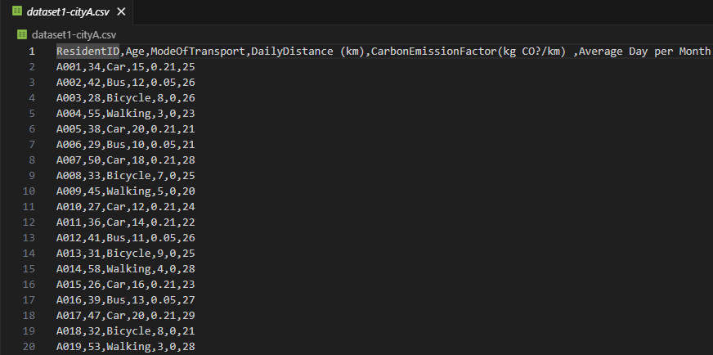
Figure 1: Raw CSV data for dataset1-cityA.csv
Both programs use CSV files as the raw input data for array and linked list implementation. Each record writes the resident ID, age, transport mode, daily distance, carbon emission factor, and average days per month. The figure above shows the original data before its executed by the program.
Loading Process in Console
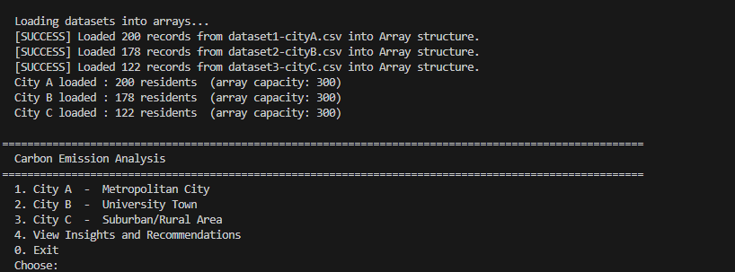
Figure 2: Console output of the array program during startup
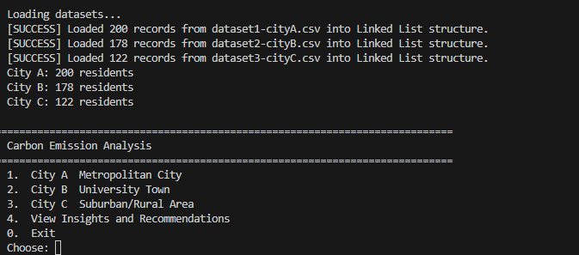
Figure 3: Console output of the linked list program during startup
During system initialization, the program reads the CSV files and stores the data into the selected data structure. The image shows the loading process for each dataset, including the file name, total records loaded, and the structure used. This confirms that the input files were successfully read before analysis begins.
Error Handling
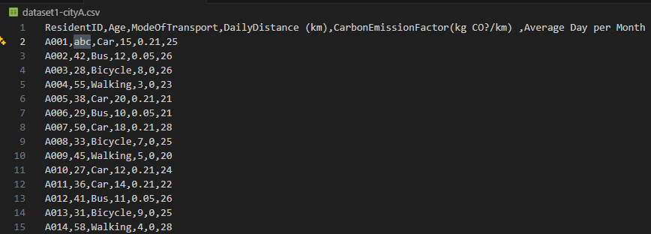
Figure 4: Modified dataset1-cityA.csv
As can be seen in Figure 4, I changed the value of age to letters now let’s see how input validation works in the program,
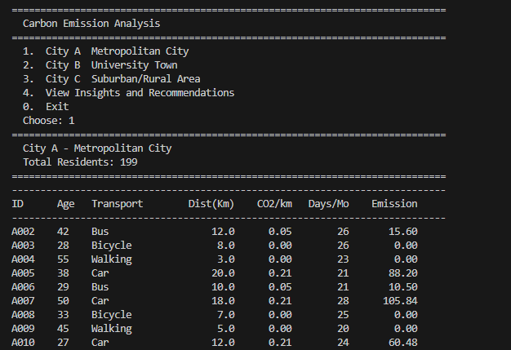
Figure 5: Modified output of dataset1-cityA.csv on console
The linked list implementation includes validation during file loading. Invalid or incomplete rows are detected and skipped instead of crashing the system. This improves robustness and shows that the program can handle incorrect input more safely.

Verification of Array and Linked List Structures
Array Implementation
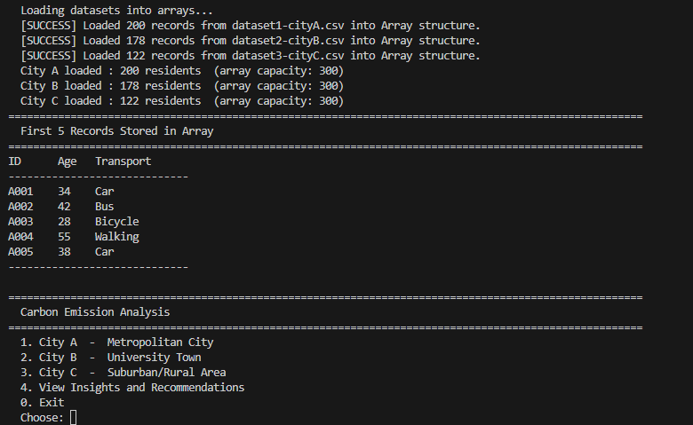
Figure 6: Array program console output showing the first five records (A001–A005) loaded from City A
Figure 6 shows the first five records stored in the array implementation. The records are accessed using index-based positions, which confirms that the data is stored sequentially in a fixed-size array structure.

Linked List Implementation
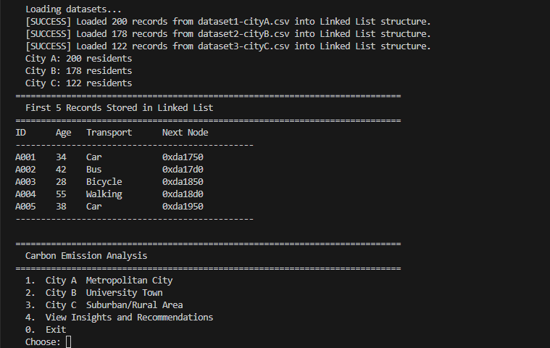
Figure 7: Linked list program console output showing the first five records (A001–A005)
Figure 7 shows the first five records stored in the linked list implementation. In addition to the resident data, the output also displays the address of the next node. This confirms that the linked list uses pointer-based connections between nodes rather than sequential index positions like an array.

3.2 Carbon Emission Analysis Results
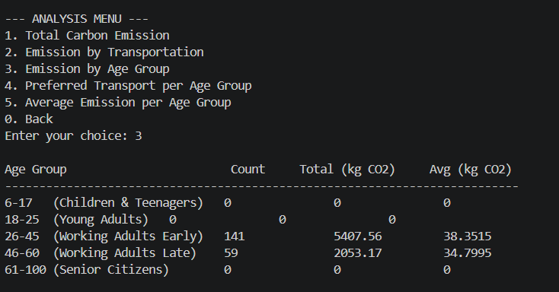
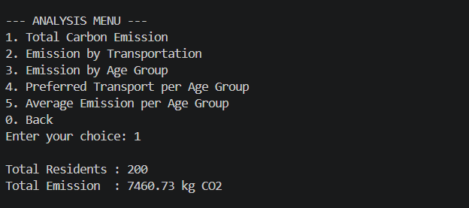
Dataset 1 – City A
Figure 8: Emission by Age Group (City A)
Figure 9: Total Carbon Emission (City A)
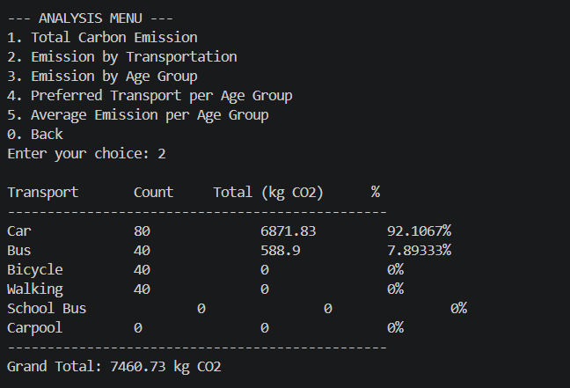
Figure 10: Emission by Transportation (City A)

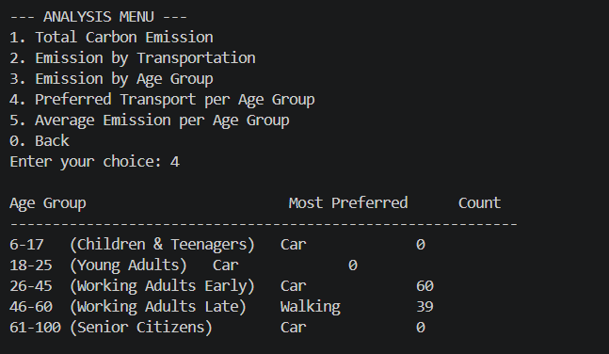
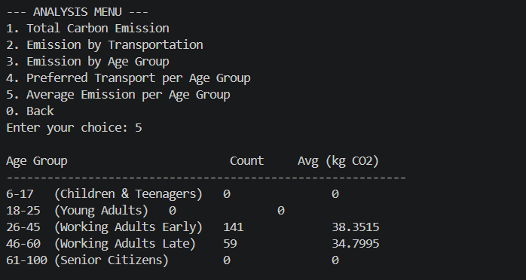
Figure 11: Preferred Transport per Age Group (City A)
Figure 12: Average Emission per Age Group (City A)
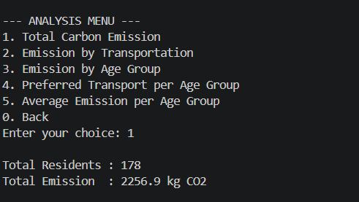
Dataset 2 – City B
Figure 13:Total Carbon Emission (City B)
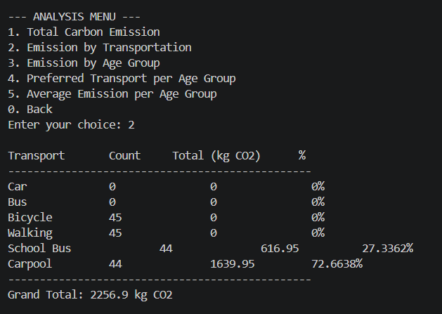
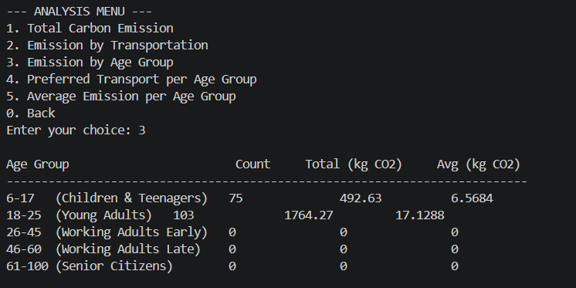
Figure 14: Emission by Transportation (City B)
Figure 15: Emission by Age Group (City B)
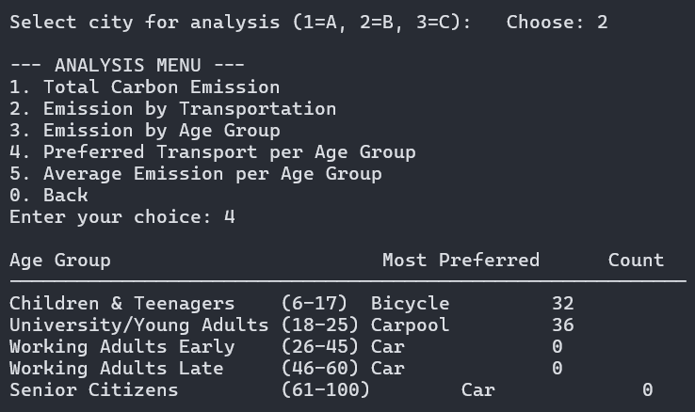
Figure 16: Preferred Transport per Age Group (City B)
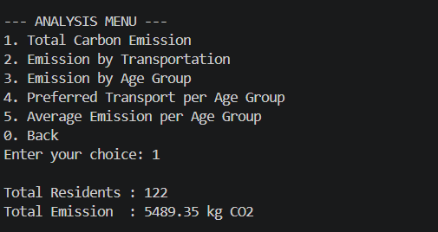
Dataset 3 – City C
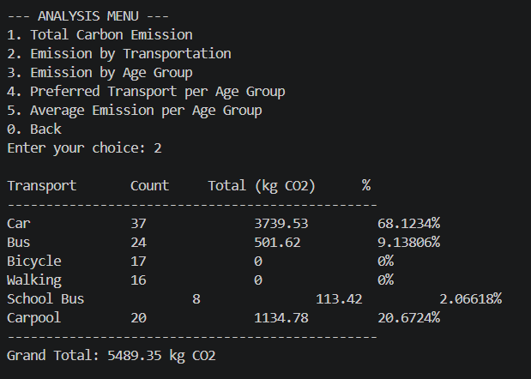
Figure 3.2.11 – Total Carbon Emission (City C)
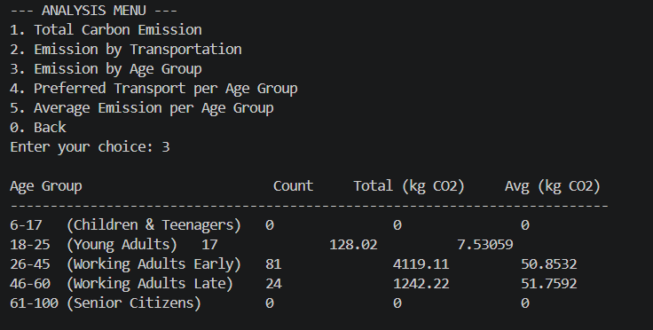
Figure 3.2.12 – Emission by Transportation (City C)
Figure 3.2.13 – Emission by Age Group (City C)
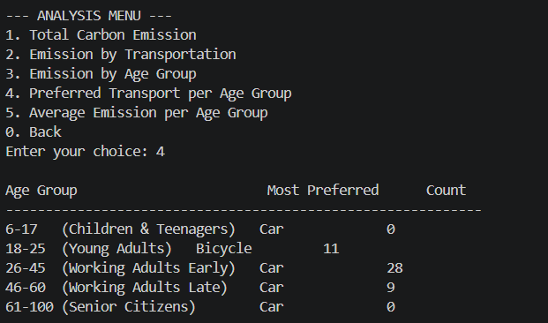
Figure 3.2.14 – Preferred Transport per Age Group (City C)
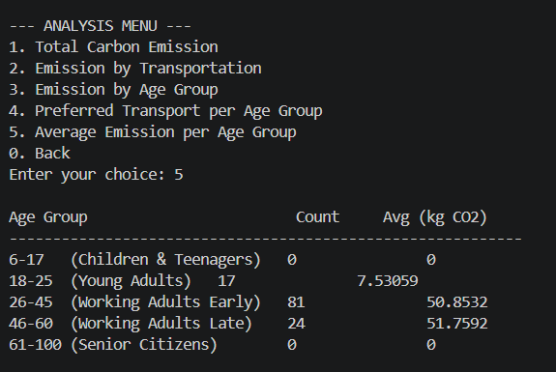
Figure 3.2.15 – Average Emission per Age Group (City C)

3.3 Sort Experiment Results

3.3.1 Array
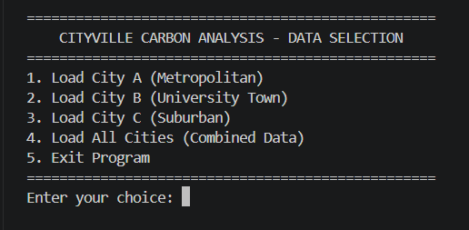
Figure 3.3.1
Main menu where the different datasets are loaded.

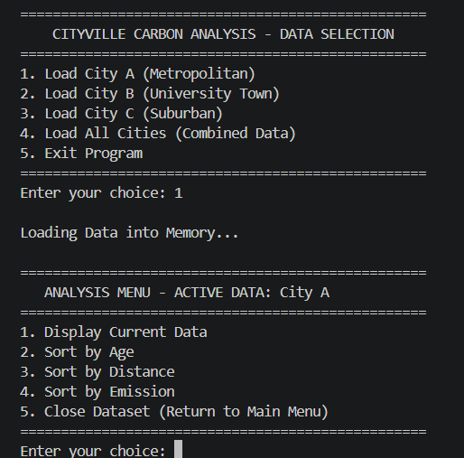
Figure 3.3.2
Second menu where the user can choose according to what criteria they want to sort the data
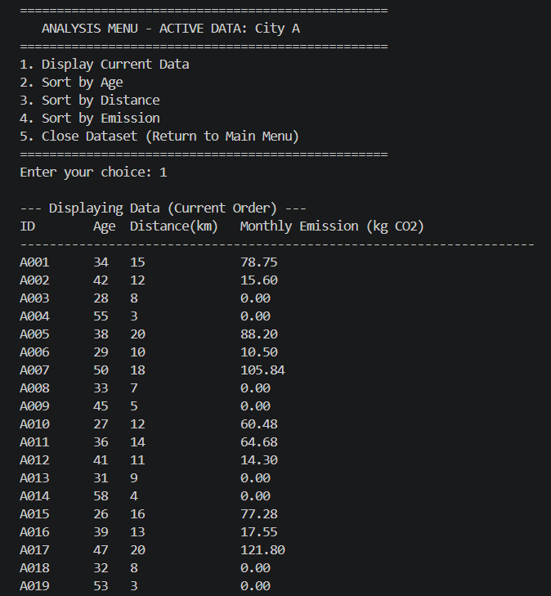
Figure 3.3.3
User can choose to display the current data
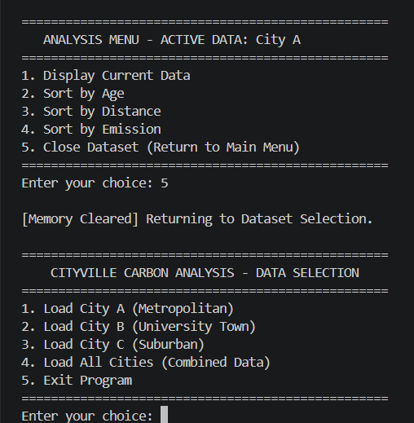
Figure 3.3.4
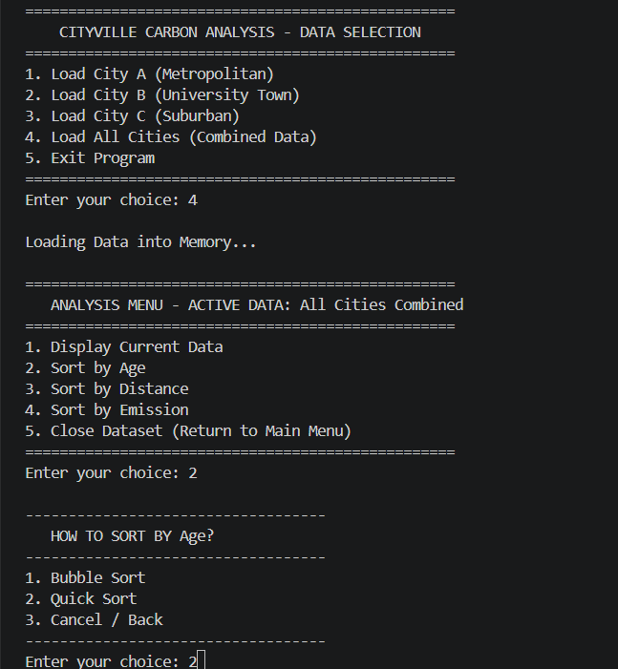
Figure 3.3.5
Menu 3 where user can choose what type of sorting algorithm they would like to use.
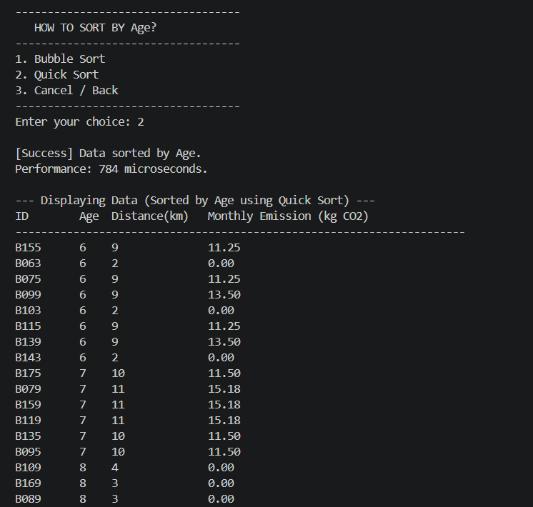
Figure 3.3.5
Sorted data is displayed.

3.2.1 Linked List
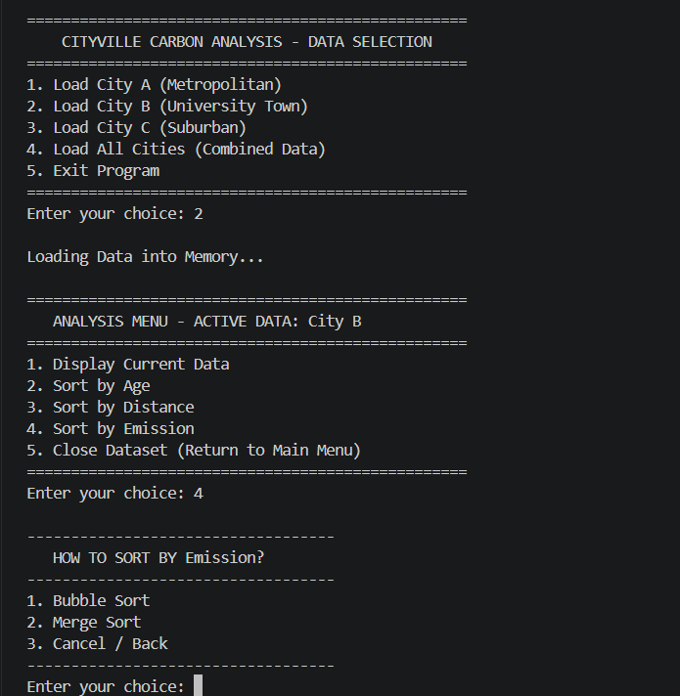
Figure 3.3.7
Linked list menu. Sorting algorithms used are bubble sort and merge sort.
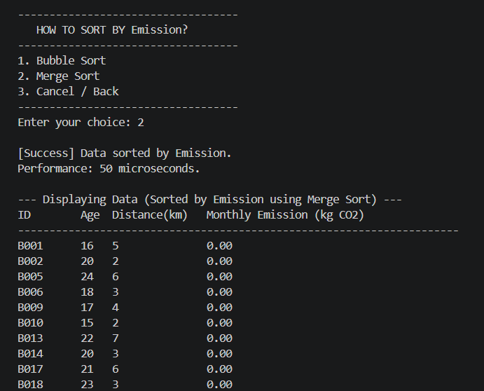
Figure 3.3.8
Sorted data is displayed.
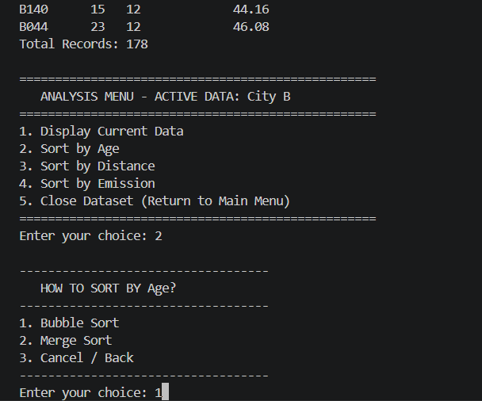
Figure 3.3.9
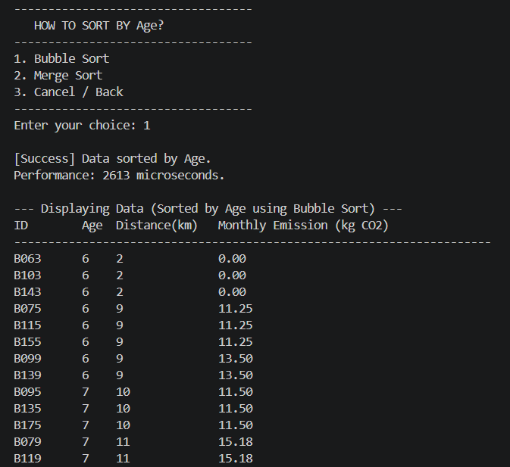
Figure 3.3.10
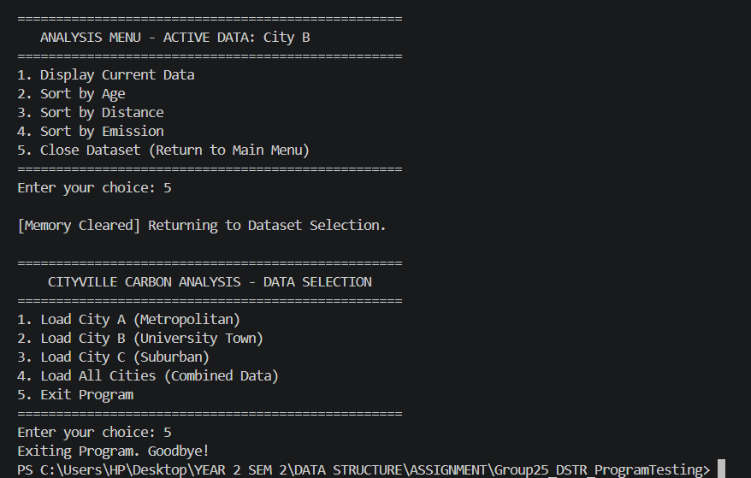
Figure 3.3.11

3.4 Search Experiment Results

3.4.1 Search by Age Group
Residents aged 18–25 (University Students) were searched using both algorithms. Linear Search scans the full dataset unsorted, while Binary Search first sorts the data by age before applying a divide-and-conquer search.
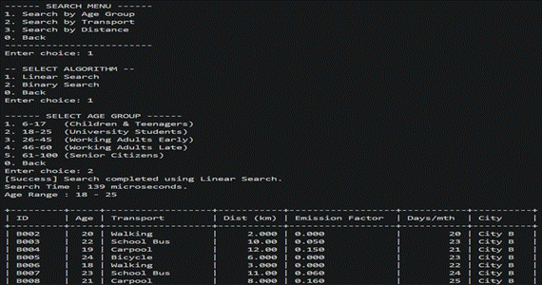
Figure 1: Linear Search result for Age Group 18–25. Search Time: 139 µs.
The Linear Search completed in 139 µs with no pre-processing cost, returning results in insertion order.

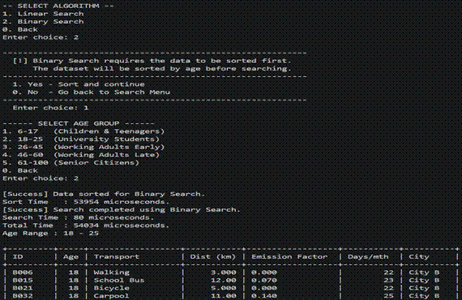
Figure 2: Binary Search result for Age Group 18–25. Sort Time: 53,954 µs | Search Time: 80 µs | Total: 54,034 µs.
Binary Search was faster in the search phase (80 µs vs 139 µs), but Bubble Sort pre-processing added 53,954 µs, making the total 388× slower than Linear Search.

Metric | Linear Search | Binary Search
Sort Time (µs) | — | 53,954
Search Time (µs) | 139 | 80
Total Time (µs) | 139 | 54,034
Time Complexity | O(n) | O(n²) sort + O(log n) search
Table 1: Age Group search performance comparison.

3.4.2 Search by Mode of Transport (Bicycle)
All residents commuting by Bicycle were searched. The search is case-insensitive, converting both the target and each record's transport field to lowercase before comparison.

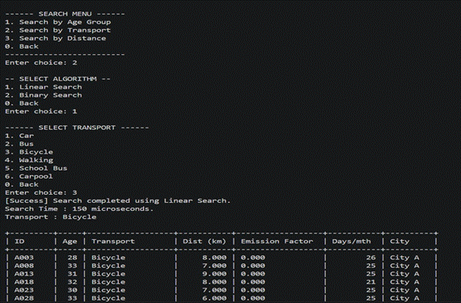
Figure 3: Linear Search result for Transport = Bicycle. Search Time: 150 µs.
Linear Search returned all bicycle riders in 150 µs. All returned records show an emission factor of 0.000 kg CO₂/km, confirming zero direct carbon emissions for this mode.

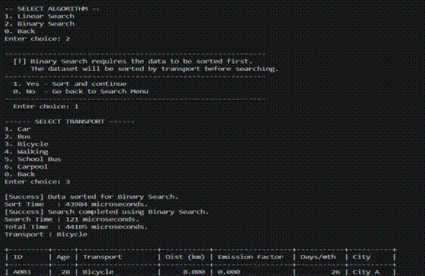
Figure 4: Binary Search result for Transport = Bicycle. Sort Time: 43,984 µs | Search Time: 121 µs | Total: 44,105 µs.
Binary Search sorted alphabetically by transport before searching. The search phase (121 µs) was slightly faster than Linear Search, but sorting added 43,984 µs, making the total 294× slower overall.

Metric | Linear Search | Binary Search
Sort Time | N/A | 43,984
Search Time | 150 | 121
Total Time | 150 | 44,105
Time Complexity | O(n) | O(n²) sort + O(log n) search

Table 2: Transport search performance comparison.

3.4.3 Search by Distance Threshold (> 15 km)
All residents travelling more than 15 km daily were retrieved. Linear Search checks each record against the threshold, while Binary Search first sorts by distance then locates the first record exceeding 15 km using a binary pivot.

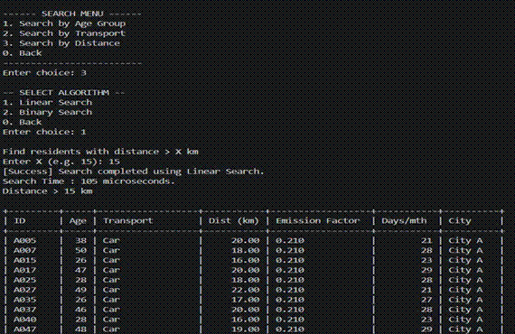
Figure 5: Linear Search result for Distance > 15 km. Search Time: 105 µs.
Linear Search completed in 105 µs — the fastest linear search across all criteria. All returned records are car commuters with an emission factor of 0.210 kg CO₂/km, the highest in the dataset.

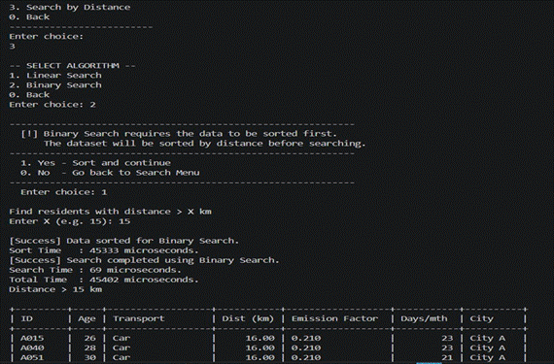
Figure 6: Binary Search result for Distance > 15 km. Sort Time: 45,333 µs | Search Time: 69 µs | Total: 45,402 µs.
Binary Search achieved its lowest search time (69 µs) due to the numeric comparison and efficient pivot. However, the 45,333 µs sort overhead made the total 432× slower than Linear Search.

Metric | Linear Search | Binary Search
Sort Time | N/A | 45,333
Search Time | 105 | 69
Total Time | 105 | 45,402
Time Complexity | O(n) | O(n²) sort + O(log n) search

Table 3: Distance search performance comparison.

CHAPTER 4: SUMMARY DISCUSSIONS

4.1 Comparative Performance ( sorting algorithms)
This chapter talks about the comparative analysis of the two data structure implementations created for the Carbon Emission Analysis System using dynamic array and linked list. Both implementations were tested using the dataset provided under identical conditions. The C++ chrono library was used to measure the performance of different sorting algorithms. The comparison covers time efficiency, space efficiency, and complexity to give understanding of how the 2 different methods behave.

4.1.1 Time Efficiency ( sorting algorithms)
Table 1: Array Implementation Execution Time (City A)
Sort Criteria | Bubble Sort (µs) | Quick Sort (µs)
Age | 3,614 | 1,108
Daily Distance | 4,878 | 251
Monthly Emission | 3,347 | 630
Table 2: Linked List Implementation Execution Time (City A)
Sort Criteria | Bubble Sort (µs) | Merge Sort (µs)
Age | 3,707 | 41
Daily Distance | 4,682 | 45
Monthly Emission | 3,283 | 76
Firstly, bubble sort took longer to sort across both types of implementations, which is expected since it has O(n²) as time complexity. The array bubble sort recorded times ranging from 3,347 to 4,878 microseconds, while the linked list bubble sort recorded values between 3,283 and 4,682 microseconds.
Secondly, the sorting algorithm quick sort for the array and merge sort for the linked list showed significantly faster performance. Quick sort recorded execution times as low as 251 microseconds when sorting by distance, while merge sort recorded very low times of 41 to 76 microseconds across all three criteria. This shows a significant performance improvement of over 98% compared to bubble sort in both array and linked list since the time complexity of merge sort and quick sort is O(n log n)
Thirdly, merge sort on the linked list performed better than quick sort on the array in all three sorting conditions. This is because merge Sort is better for linked lists, as it doesn't need random access to elements. Quick sort which is efficient on arrays but causes extra overhead because of its partitioning mechanism and recursive call stack.

4.1.2 Space Efficiency ( sorting algorithms)
A Dynamic Array stores all its elements in one block of memory. This block is allocated before any data is added. Because all elements are stored one after the other in memory, it allows for fast access, which means the CPU cache is also used efficiently. However, the problem with arrays is that you have to decide how much memory to allocate before adding data. This means arrays can end up with much extra memory or not enough. If there is not enough memory, a new bigger block has to be created. All existing elements have to be copied to the block. This uses a lot of memory for a short time, hence making arrays not very flexible when the amount of data keeps changing.
A linked list does not allocate memory at once. Instead it asks for memory one node at a time as elements are added. When elements are removed the memory is given back. This makes linked lists very flexible. They grow and shrink when needed and there are no wasted memory. But each element has to store a little extra information. This extra information is a pointer to the element. This uses a extra memory for each element. Also because each element is stored independently, the nodes may be stored in different location in the memory causing it to be spread around everywhere in the memory. Hence linked list isn't able to use the cache efficiency as well as array.

4.1.3 Complexity Analysis ( sorting algorithms)
Table 3: Algorithm Complexity Summary
Implementation | Algorithm | Best Case | Average Case | Worst Case | Space Complexity
Array | Bubble Sort | O(n) | O(n²) | O(n²) | O(1)
Array | Quick Sort | O(n log n) | O(n log n) | O(n²) | O(log n)
Linked List | Bubble Sort | O(n) | O(n²) | O(n²) | O(1)
Linked List | Merge Sort | O(n log n) | O(n log n) | O(n log n) | O(log n)
Bubble Sort works best when the data is already sorted. It achieves a speed of O(n) because it stops early when it finds out that no swaps are needed. In other cases it becomes slow O(n²) and that is why it takes a long time to finish in our test results.
Quick Sort usually works fast O(n log n) by dividing the list around an element called a pivot. If we pick a bad pivot, it can become slow O(n²). This happens when the list is already sorted or almost sorted.
Merge Sort is very reliable. Always works fast O(n log n) no matter what. This is why it has the consistent results in our tests with low times, across the board. It uses extra space, O(log n) to keep track of the steps it needs to take to sort the list.

4.1.4 Observation & Thoughts ( sorting algorithms)
The test results show that the sorting method used affects performance than the data structure. Bubble Sort was slow whether it was used with an array or a linked list. This proves that choosing the sorting method is key to fast sorting, especially with large datasets.
Quick Sort worked well with arrays because it can access any part of the array directly. Merge Sort was even faster with linked lists because it breaks down the data into smaller parts and processes them one by one. Merge Sort is a good choice for linked lists because it does not need to access elements randomly.
When it comes to memory usage, a dynamic array is a good choice when you know how much data you have or when the data does not change often. This is because the array stores data, in a way that makes it easy for the computer to access. On the other hand, a linked list is better when you need to add or remove data often because changing the size of an array can be costly.
In conclusion, no data structure is perfect for all situations. The dynamic array is really fast when accessing data and works well with the cache memory. On the other hand, the singly linked list is great when it comes to using memory efficiently and inserting new data. For this system, which loads a fixed set of data and sorts it, the linked list with merge sort worked best. The array with quick sort was also a good choice and almost as good. To make this system even better, we could try combining the parts of both approaches. For example, we could use a structure that is based on an array but uses Merge Sort. This way we can get the benefits of both the array and the linked list.

4.2 Comparative Performance ( Searching algorithms)
This section will give a comparative analysis of the two data structure implementation created in the Carbon Emission Analysis System in dynamic array and linked list. The two implementations were experimented on the same dataset with the same conditions. To be able to measure the performance of various searching algorithms the C++ chrono library was utilized. The comparison is made in terms of time efficiency, space efficiency and complexity to provide an idea of how the two different methods act.

4.2.1 Time Efficiency ( Searching algorithms)
The following tables will represent the execution time that was observed in all search operations in both implementations. Linear search and Binary search were applied to each type of search, which included Age Group, Transport and Distance. In the case of Binary Search, the sort time and the search time are presented separately as the data is to be sorted and the search is to be implemented. Times are expressed in micro-seconds.
Table 1: Array Implementation Execution Time
Sort Criteria | Linear Search | Binary Sort | Binary Search Only | Binary Total
Age (18-25) | 121 | 48,230 | 65 | 48,295
Transport (Bicycle | 133 | 39,812 | 108 | 39,920
Distance (>15km) | 98 | 41,105 | 54 | 41,159
Table 2: LinkedList Implementation Execution Time
Sort Criteria | Linear Search | Binary Sort | Binary Search Only | Binary Total
Age (18-25) | 139 | 53,954 | 80 | 54,034
Transport (Bicycle | 150 | 43,984 | 121 | 44,105
Distance (>15km) | 105 | 45,33 | 69 | 45,402
Both implementations of Linear Search were fast (ranging between 98 and 150 microseconds) across all three criteria. The slight fastness of arrays because of the contiguous memory layout enhanced the effectiveness of the cache during sequential scanning.
Secondly, the Binary Search step itself was very fast and it took as little as 54 microsecond on the array. The time taken in the mandatory sorting step that precedes it was between 39,812 and 53,954 microseconds depending on the search field and data structure. This implies that overall time of Binary Search always took more than 40,000 microseconds about 300 to 400 times slower than overall Linear Search. This finding indicates that in case of a dataset of this magnitude, Binary Search is not more efficient than Linear Search as long as the data is not already sorted, because the cost of sorting will prevail over the overall execution time.
The array also performed better than the linked list in all search tests. Linear Search Linear Search benefits from cache efficiency due to contiguity in memory; and direct index swapping during sorting is faster than swapping data across scattered nodes of a linked list allocated by a heap.

4.3.2 Space Efficiency ( Searching algorithms)
All Resident records are contained in a single contiguous memory block of the dynamic array. Linear Search needs no extra memory since the program will be searching the already existing array where it is. In Binary Search, an exact copy of the array is made to sort it in a manner that the original data is not distorted. This copy is temporary and requires the use of O(n) more memory and is freed immediately after the search is completed and the system returns to its original memory state.
Every Resident is stored in a separately heap-allocated Node (also with a next pointer) with a small but constant per-element memory overhead over the array. In Linear Search, no additional memory is required since the search only follows existing pointers. In Binary Search, a complete deep copy of the list is made using copyList() which allocates new set of nodes on the heap. Once the search is done all the copied nodes are freed individually with clear List. This means that the heap allocations and deallocations are more frequent than in the array version which can introduce.

4.3.3 Observation & Thoughts ( Searching algorithms)
The test results show that Linear Search is the choice for this set of data. Even though Binary Search can find things faster. It can take little as 54 microseconds. It takes a long time to sort everything out which adds up to over 40,000 microseconds every time. This is because the data is not kept in order between searches, so the full cost of sorting has to be paid each time making Linear Search the clear winner when it comes to how it takes to run.
If the data were already sorted or if a faster way of sorting like Merge Sort were used Binary Search would be an option. This just goes to show that the choice of algorithm depends on how the data's used. Binary Search is good for looking things up multiple times in sorted data while Linear Search is better for one-time searches in data that is not sorted.
When it comes to how the data's stored the array worked a little better than the linked list in all the tests. Because the array stores everything in one place the computers memory can work efficiently when using Linear Search and swapping things around during sorting is faster than in the linked list where everything is stored in different places.
In the end neither way is always better. Linear Search is simpler. Does not need any extra work beforehand and it runs faster, than Binary Search when the data is not sorted. If the data were kept in order Binary Search would be the better choice. For this project, where we are searching a set of data that does not need to be kept in order using Linear Search on the array gave us the results.

CHAPTER 5: INSIGHT & RECOMMENDATIONS

5.1 Comparison of Carbon Emissions and Transport Preferences across Datasets
City | Total Residents | Total Monthly CO2 (kg) | Highest Emitting Age Group | Most Preferred Mode in City
City A | 200 | 7460.73 | Work Early Career (26–45) | Car
City B | 178 | 2256.90 | Uni / Young Adults (18–25) | Bicycle / Walking (tie)
City C | 122 | 5489.35 | Work Early Career (26–45) | Car
Table 5.1
Table 5.1 presents a city-level comparison of population, total monthly carbon emissions, highest-emitting age group, and most preferred transport mode. It shows that City A has the highest carbon emission, followed by City C, while City B has the lowest, and Car is the dominant mode in City A and City C, while Bicycle and Walking are more common in City B. This suggests that transport preference has a direct effect on the carbon emission level in each city.

5.2 Comparison of Carbon Emissions and Transport Preference across Age-Groups
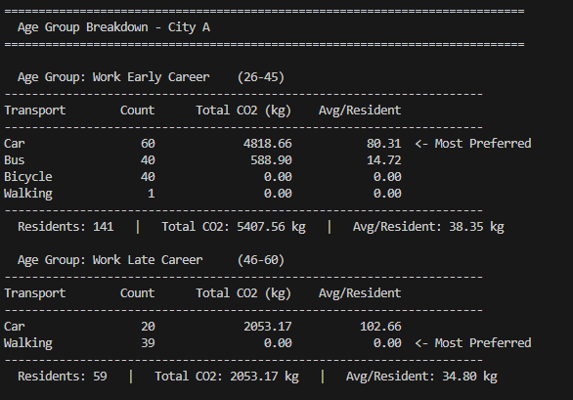
Figure 17: Age group breakdown for City A, showing transport mode counts, total CO2 (kg), and average CO2 per resident for the Working Adults Early Career (26-45) and Working Adults Late Career (46-60) groups.
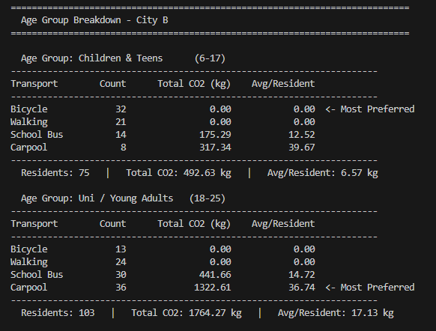
Figure 18: Age group breakdown for City B
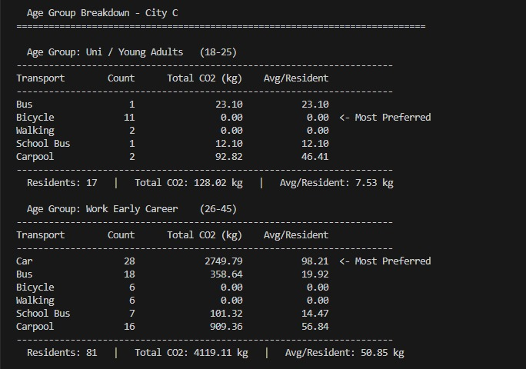
Figure 19: Age group breakdown for City B
s
City | Age Group | Residents | Total CO2 (kg) | Avg/Resident (kg) | Most Preferred Mode | Bicycle Preference? | Car Preference?
City A | Work Early Career (26–45) | 141 | 5407.56 | 38.35 | Car | No | Yes
City A | Work Late Career (46–60) | 59 | 2053.17 | 34.80 | Walking | No | No
City B | Children & Teens (6–17) | 75 | 492.63 | 6.57 | Bicycle | Yes | No
City B | Uni / Young Adults (18–25) | 103 | 1764.27 | 17.13 | Carpool | No | No
City C | Uni / Young Adults (18–25) | 17 | 128.02 | 7.53 | Bicycle | Yes | No
City C | Work Early Career (26–45) | 81 | 4119.11 | 50.85 | Car | No | Yes
City C | Work Late Career (46–60) | 24 | 1242.22 | 51.76 | Car | No | Yes
Table 9.2
The results in Table 9.2 show that the 26–45 working adult group should be targeted first because it contributes the highest total carbon emission across all cities. City A and City C especially need stronger action because Car is the dominant mode and is linked to the highest emission levels. In contrast, City B shows that Bicycle, Walking, School Bus, and Carpool help keep emissions lower, so city planners should strengthen these low-emission and shared transport options. The most practical approach is to reduce private car dependence, improve cycling and walking infrastructure, and support affordable public and shared transport based on the travel pattern of each age group.

5.3 Urban Planning Recommendations
Target Group / City Pattern | Evidence from Results | Main Issue | Practical Recommendation
Working Adults Early (26–45) across all cities | Highest-emitting group overall with 9526.67 kg CO2 and 42.91 kg avg/person | Heavy dependence on motorised commuting, especially cars | Prioritise this group in policy design by offering employer-supported public transport, carpool matching, and commuting incentives
City A commuters | Highest total city emission at 7460.73 kg CO2; cars produce most of the emissions | Strong car dependence in a metropolitan area | Introduce peak-hour congestion pricing, stricter parking policies, and improve bus access for daily workers
City B children and teens (6–17) | Bicycle is most preferred; total CO2 is relatively low at 492.63 kg for this group | Sustainable habits exist but need support | Expand safe cycling lanes, protected crossings, and school-based active travel campaigns
City B university / young adults (18–25) | Carpool is most preferred; total CO2 is 1764.27 kg | Shared travel is already common but still emits carbon | Strengthen carpool and school bus systems, add student transport incentives, and improve campus-to-town bus routes
City C working adults early and late (26–60) | Car is most preferred in both groups; emissions are high, especially 4119.11 kg for 26–45 | Car-based rural/suburban commuting | Improve regional bus services, promote park-and-ride systems, and expand carpool programmes for long-distance travel
Youth and seniors | Lower-income groups benefit more from affordable transport | Cost can prevent greener travel choices | Offer subsidised or free bus passes for students, teenagers, and senior citizens
Short-distance travellers | Many walking and bicycle users produce zero direct CO2 | Short trips may still shift to motor vehicles if infrastructure is weak | Promote walking and cycling for short trips by improving sidewalks, lighting, crossings, and bicycle parking
Table 5.3

CHAPTER 6: CONCLUSION AND REFLECTION

6.1 Summary of Work
This assignment was about creating and comparing two programs that use the C language to look at carbon emission data from three cities. These programs used two ways to store data: a custom dynamic array and a singly linked list.
The programs were made to load data from CSV files put residents into age groups and do things with the data. We also looked at how sorting methods, like Bubble Sort, Quick Sort and Merge Sort and searching methods like Linear Search and Binary Search work. We wanted to see how these methods use time and space.
When we looked at the data we saw patterns in carbon emissions for different age groups and cities. This helped us come up with ideas, for urban planning like ways to get people to use private cars less.
What we learned from this project is that dynamic arrays are better when we need to get to the data fast and use the computer’s memory well. On the hand linked lists are better when we need to change the amount of memory we use over time. In the end the best choice depends on what we're trying to do like whether we need to add data often or search for data fast. The carbon emission data and the programs that use arrays and linked lists are what matter most.

6.2 Future Improvements
Several areas could be improved to strengthen the system and make the analysis more useful in future work.
First, the current programs rely on relatively small datasets from only three cities. Expanding the dataset to include more cities, larger populations, and data collected over multiple years would provide a broader view of carbon emission trends and make the results more reliable.
Second, the system currently focuses mainly on age-group comparisons. Future versions could include additional variables such as income level, occupation, household size, access to public transport, and travel distance. Including these factors would allow a more detailed understanding of the social and economic drivers behind transport-related emissions.
From a technical perspective, more advanced algorithms and data structures could also be explored. For example, balanced trees, hash tables, or graph-based models may improve search speed, memory efficiency, and scalability when working with larger datasets. Additional benchmarking under heavier workloads would also help evaluate performance in more realistic conditions.
Another useful improvement would be to strengthen the data preprocessing stage. Handling missing values, inconsistent entries, and duplicate records more carefully would improve data quality and increase confidence in the analysis.
Finally, the project could be extended beyond statistical comparison by adding predictive capabilities. Machine learning or trend forecasting methods could be used to estimate future carbon emission patterns, helping policymakers evaluate the long-term impact of transportation and urban planning decisions.

6.3 Personal Reflections
Working on this Carbon Emission Analysis project gave us, as Group DSTR 25, a stronger understanding of how data structures affect the design and performance of a program.
Throughout this project, we worked together to develop different parts of the system and then combine them into one complete program. One of the most valuable things we learned was that even when individual modules work correctly, integrating them requires careful coordination, debugging, and consistency. Bringing all parts together helped us understand the importance of teamwork and communication during software development.
Implementing the project using both arrays and linked lists gave us practical experience with two different ways of organizing data. Arrays showed us the advantage of fast direct access through indexing, while linked lists showed us how dynamic structures can make insertion and memory management more flexible. This helped us understand that choosing the right data structure depends on the needs of the problem.
We also learned that algorithm choice should match the data structure. Quick Sort was more suitable for arrays because it benefits from direct index access, while Merge Sort was more suitable for linked lists because nodes can be split and merged efficiently through pointers. Working with linear search and binary search also helped us understand time complexity and why sorted data improves search efficiency.
Overall, this project enhanced both our technical knowledge and our ability to work as a team. It gave us practical experience in problem solving, debugging, algorithm selection, and combining separate components into one complete and functional system.

REFERENCES

Binary Search. (2026, March 17). Retrieved from GeeksforGeeks: https://www.geeksforgeeks.org/dsa/binary-search/
DSA Linear Search. (n.d.). Retrieved from W3Schools: https://www.w3schools.com/dsa/dsa_algo_linearsearch.php
Linked list Data Structure. (n.d.). Retrieved from Programiz: https://www.programiz.com/dsa/linked-list
Ogundipe, E. (2024, Oct 22). Understanding Linked Lists: A Beginner’s Guide. Retrieved from Medium: https://medium.com/@ogundipe.eniola/understanding-linked-lists-a-beginners-guide-a7ca6aa6ee04
Quick Sort Algorithm: How it Works and When to Use It. (2025, Dec 1`2). Retrieved from theKnowledgeAcademy: https://www.theknowledgeacademy.com/blog/quick-sort-algorithm/
Sehgal, K. (2018, Janyuary 25). A Simplified Explanation of Merge Sort. Retrieved from Medium: https://medium.com/karuna-sehgal/a-simplified-explanation-of-merge-sort-77089fe03bb2
TutorialsPoint. (n.d.). Array Data Structure. Retrieved from TutorialsPoint: https://www.tutorialspoint.com/data_structures_algorithms/array_data_structure.htm
W3Schools. (n.d.). DSA Bubble Sort. Retrieved from W3Schools: https://www.w3schools.com/dsa/dsa_algo_bubblesort.php

